**TO: American Lobster Management Board**

**FROM: American Lobster Technical Committee**

**DATE: October 7, 2024**

**SUBJECT:** **2024 American Lobster Data Update**

**Data Update**

An annual Data Update process between American lobster stock assessments was recommended during the 2020 stock assessment to more closely monitor changes in stock abundance. The objective of this process is to present information—including any potentially concerning trends—that could support additional research or consideration of changes to management. Data sets updated during this process are generally those that indicate exploitable lobster stock abundance conditions expected in subsequent years and include:

* Young-of-year (YOY) settlement indicators
* Trawl survey indicators, including recruit abundance (71‐80 mm carapace length lobsters) and survey encounter rate
* Ventless trap survey (VTS) sex‐specific abundance indices (53 mm+ carapace length lobsters)

This is the fourth Data Update and provides an update of last year’s review with the addition of 2023 data. Indicator status (negative, neutral, or positive – see table below) was determined relative to the percentiles of the stock assessment time series (i.e., data set start year through 2018).

|  |  |  |  |
| --- | --- | --- | --- |
| **Indicator** | **< 25th percentile** | **Between 25th and 75th percentile** | **> 75th percentile** |
| YOY settlement (larval or YOY) | Negative | Neutral | Positive |
| Trawl survey recruit abundance | Negative | Neutral | Positive |
| Trawl survey encounter rate | Negative | Neutral | Positive |
| Ventless trap survey abundance | Negative | Neutral | Positive |

An updated status based on the mean value over the most recent five years (2019-2023) is provided for each time series, for comparison to the five-year means provided during the stock assessment (2014-2018). This treatment of data is consistent with model-free indicators provided during stock assessments (see Section 5 in the 2020 stock assessment report for more detail). VTS abundance indices have been added to the indicators used in the stock assessment for this Data Update process. Note that updated five-year means (2019-2023) for several trawl survey-based indicators remain impacted by COVID-19 survey disruptions and a new (unrelated to COVID-19) survey disruption to the NEFSC trawl survey in Spring 2023. Additionally, the NEFSC Fall time series has not been updated with 2023 data. The TC and SAS are reviewing potential changes to handling of the NEFSC survey data as part of the ongoing benchmark assessment, including how the Albatross / Bigelow vessel calibration is handled, implementation of gap-filling procedures for missed strata, and removal of one stratum from the Georges Bank survey index because it is no longer sampled. Thus, these changes need to be evaluated through peer review of the assessment before further updates of indicators are provided. In the interest of time and anticipated impacts from the changes described, the TC decided not to calculate Fall 2023 indices using the old calibrations and data methods. Indices affected by this issue will be identified with an asterisk (*). Please see the appendix for details on other data changes. Below are the results of the data updates by sub-stock.

***Gulf of Maine (GOM)***

Overall, Gulf of Maine indicators for recruits and adults continue to show declines from time series highs observed during the stock assessment, while YOY indicators show some improvement.

* YOY conditions showed improvements since the stock assessment (Table 1 and Figure 1).
  + Updated status for five-year means were all neutral, indicating improvement since the stock assessment when two of five means were negative (both southwest areas).
  + All ME indices have shown consistent increasing trends since a recent low in 2021. 2023 values for two indices improved from negative or neutral to positive status while the other three indices remained neutral.
  + It’s important to note that changes in YOY indicators are not expected to be detected in the recruit indicators for several years.
* Trawl survey recruit abundance indicators showed signs of decline since the stock assessment (Table 2 and Figure 2).
  + Three of the updated five-year means changed status from positive to neutral since the stock assessment. The other three remained positive, though two (NEFSC) did not include additional data since 2022* when they were also positive. All three indicators that have declined to neutral status since the assessment are for inshore GOM waters.
  + 2023 values for all inshore GOM surveys were neutral status, a decline for one additional indicator from positive to neutral since 2022.
  + Five of six indicator values were not available for 2020 due to COVID-19 sampling restrictions.
* Trawl survey encounter rates show declines inshore since the stock assessment (Table 3 and Figure 3).
  + All four of the updated five-year means for inshore indicators were neutral, whereas only one was neutral during the stock assessment. Five-year means for the two offshore indicators remain positive, though they do not include additional data since 2022* when they were also positive.
  + Note that the ME/NH survey encounter rates (spring and fall) are still high relative to other surveys.
  + Five of six indicator values were not available for 2020 due to COVID-19 sampling restrictions.
* Ventless trap survey indices show abundance declining since the stock assessment (Table 4 and Figure 4).
  + Status determinations for four of eight updated five-year means were negative and four were neutral, compared to four positive means and no negative means during the stock assessment.
  + The indicator for Area 513 has been more stable over recent years than the indicators for the other three areas.
  + While the status of most 2023 indicators remained the same (neutral or negative), the values were similar or improved over the 2022 values in all areas except 511 (both sexes) which continued to decline and changed from neutral to negative status between 2022 and 2023.

***Georges Bank (GBK)***

Overall, Georges Bank indicators show slight improvement since the stock assessment, though updates include no additional data since 2022*. Note that there are no YOY or VTS indicators for this sub-stock area.

* Trawl survey recruit abundance indicators showed slight improvements (Table 5 and Figure 5).
  + One updated five-year mean changed from neutral to positive since the stock assessment, while the other remained neutral.
  + 2022 values were both positive and relatively high, as were 2021 values.
  + No values were available for 2020 due to COVID-19 sampling restrictions.
  + These indicators tend to be noisier than some of the other abundance indicators, with high interannual variability and lack of discernible trends.
* Trawl survey encounter rates showed similar conditions since the stock assessment (Table 6 and Figure 6).
  + The updated means both remained positive.
  + No values were available for 2020 due to COVID-19 sampling restrictions.

***Southern New England (SNE)***

Overall, Southern New England indicators show continued unfavorable conditions with some further signs of decline since the stock assessment. Most updated indicators are at or near time series lows.

* YOY conditions were negative across the stock with some decline since the stock assessment (Table 7 and Figure 7).
  + Updated status for the five-year means were all negative, whereas one of three was neutral during the stock assessment.
  + No YOY have been caught during the MA survey for the last nine years.
  + It is very important to note that the CT/ELIS YOY values for 2022 and 2023 are calculated from only one and two observed larvae, respectively (marked with asterisks in Figure 7). Survey sampling methods changed in these years due to reduced encounters of lobsters, making interpretation of these two years problematic relative to the rest of the time series. The Stock Assessment Subcommittee will evaluate this dataset during the ongoing benchmark assessment to determine its use in future assessments and Data Updates.
* Trawl survey recruit abundance indicators showed declines since the stock assessment (Table 8 and Figure 8).
  + Updated status for the five-year means were all negative, with three of eight moving to negative conditions since the stock assessment. Two of these indicators (NEFSC) did not include additional data since 2022* when they were also negative.
  + No recruit lobsters were observed in 2023 for three of six available indicators.
  + Six of eight indicator values were not available for 2020 due to COVID-19 sampling restrictions.
* Trawl survey encounter rates showed deteriorating conditions since the stock assessment (Table 9 and Figure 9).
  + Updated status for the five-year means were all negative, with two changing from neutral to negative since the stock assessment. Two of these indicators (NEFSC) did not include additional data since 2022* when they were also negative.
  + No lobsters of any size were observed in 2023 for two of six available indicators.
  + Six of eight indicator values were not available for 2020 due to COVID-19 sampling restrictions.
* Ventless trap survey indices show continued declines since the stock assessment (Table 10 and Figure 10).
  + The status for three updated five-year means changed from neutral to negative since the stock assessment. The other updated five-year mean remained neutral.
  + All 2023 annual values had negative status; this is the second year in a row that annual status has been negative across all indicators.
  + It is important to note that the ventless trap survey has only taken place during depleted stock conditions coinciding with an adverse environmental regime, so interannual variability can be misleading without the context of a longer time series encompassing varying stock conditions.

**Tables and Figures**

Table 1. GOM abundance indicators: YOY indices.

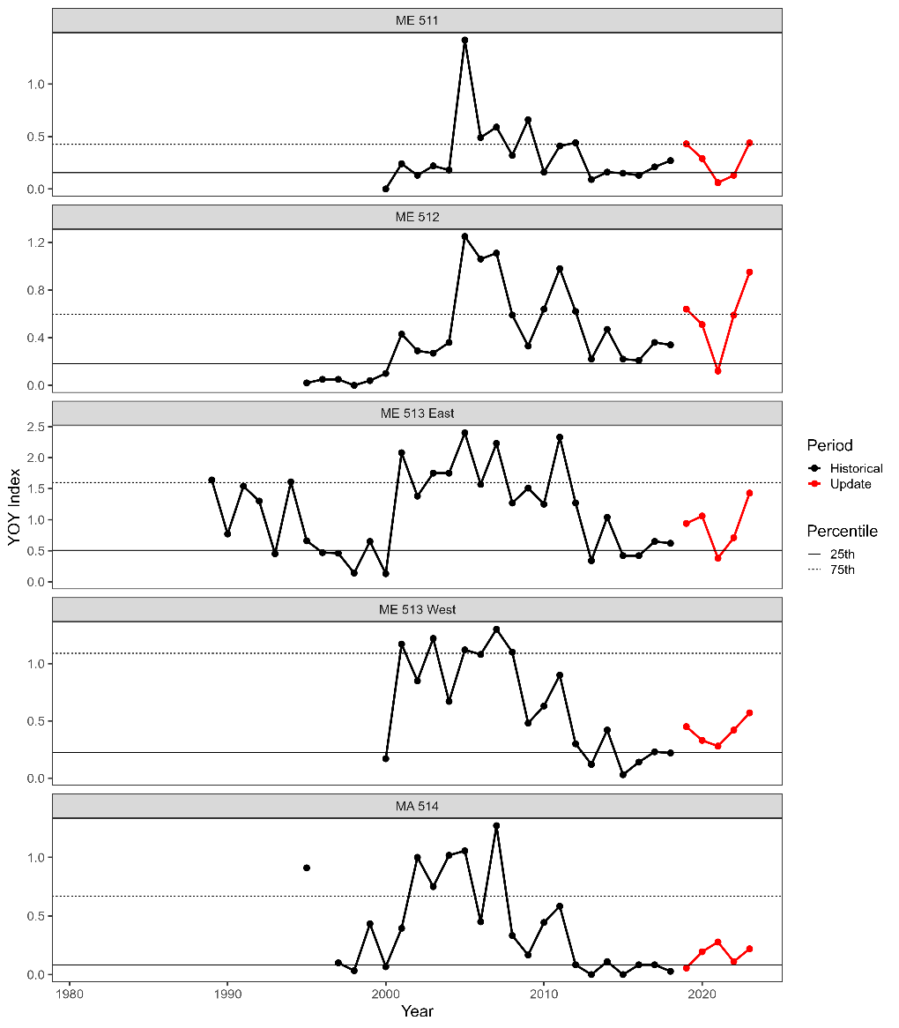

Figure 1. GOM abundance indicators: YOY indices.

Table 2. GOM abundance indicators: trawl survey recruit abundance.

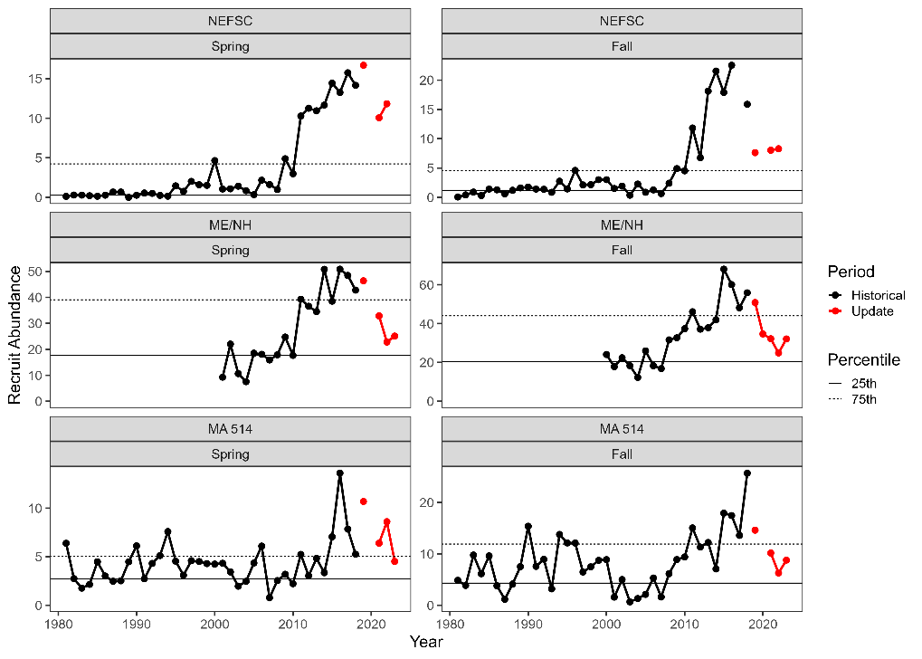

Figure 2. GOM abundance indicators: trawl survey recruit abundance.

Table 3. GOM abundance indicators: trawl survey encounter rate.

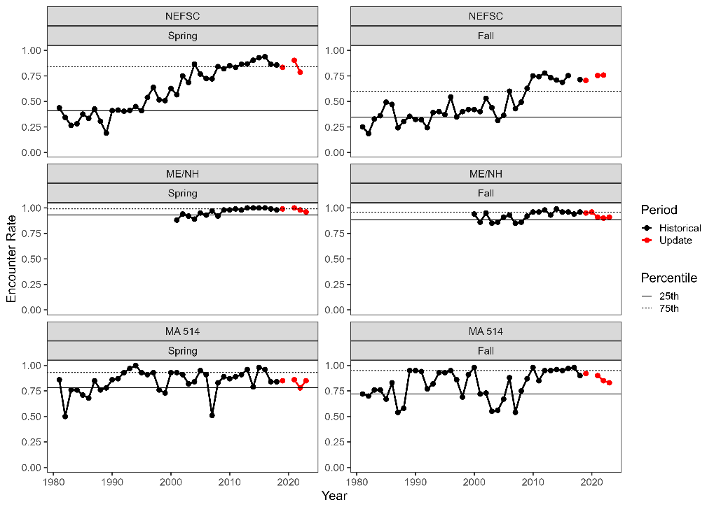

Figure 3. GOM abundance indicators: trawl survey encounter rate.

Table 4. GOM abundance indicators: ventless trap survey abundance.

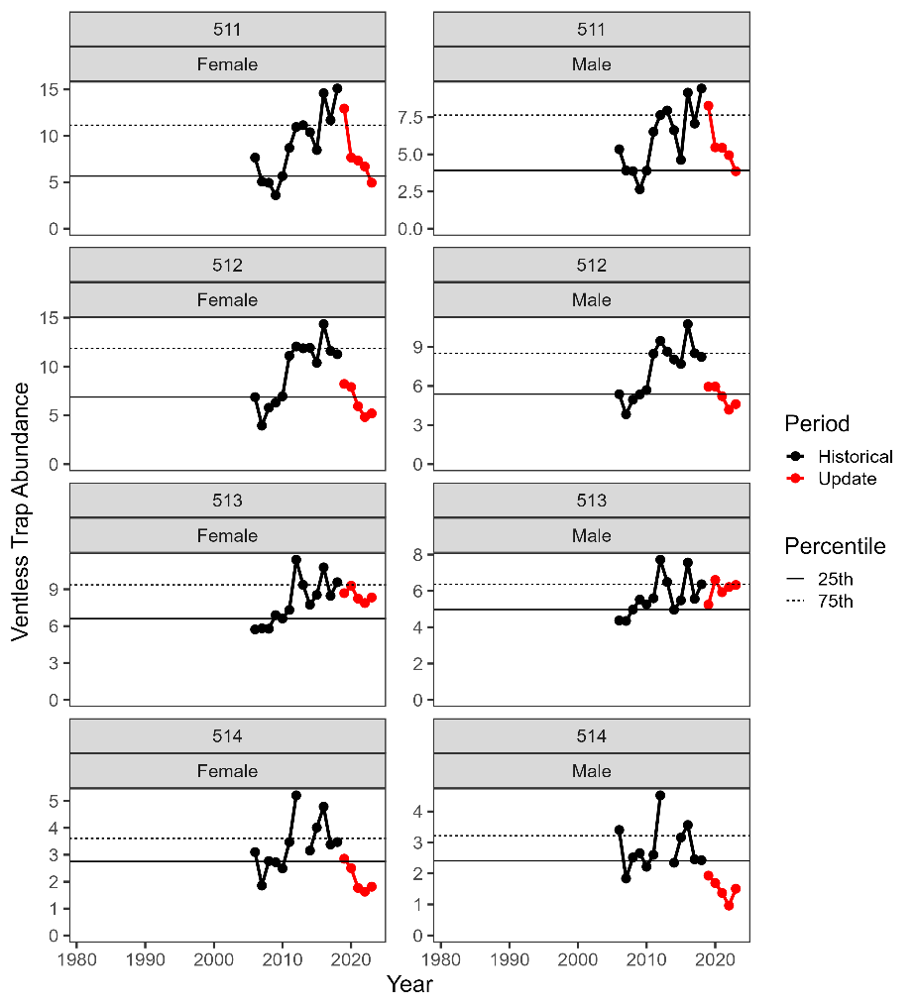

Figure 4. GOM abundance indicators: ventless trap survey abundance.

Table 5. GBK abundance indicators: trawl survey recruit abundance.

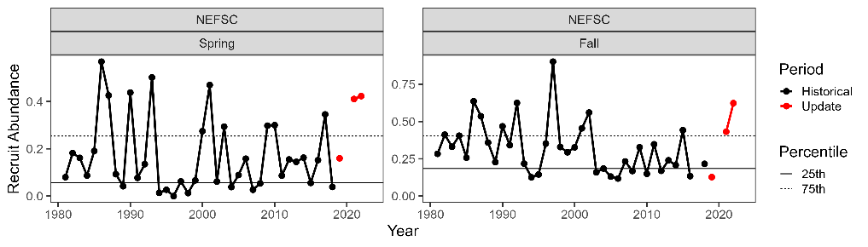

Figure 5. GBK abundance indicators: trawl survey recruit abundance.

Table 6. GBK abundance indicators: trawl survey encounter rate.

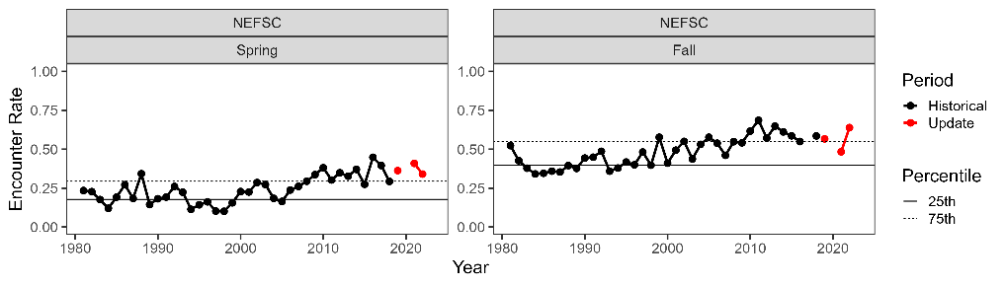

Figure 6. GBK abundance indicators: trawl survey encounter rate.

Table 7. SNE abundance indicators: YOY indices.

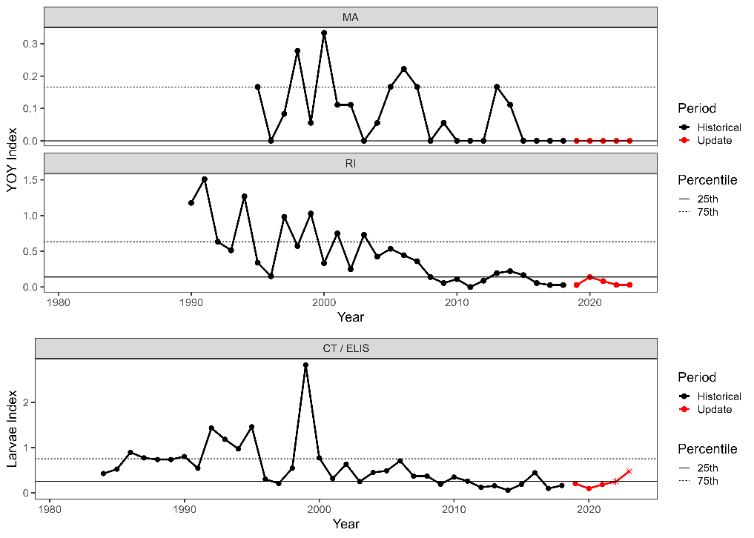

Figure 7. SNE abundance indicators: YOY indices. ***Asterisks indicate years with survey changes.***

Table 8. SNE abundance indicators: trawl survey recruit abundance.

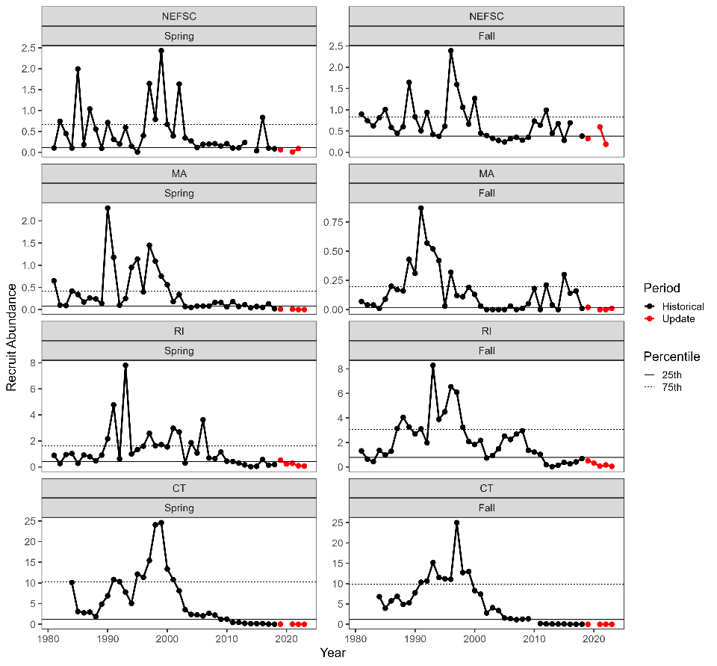

Figure 8. SNE abundance indicators: trawl survey recruit abundance.

Table 9. SNE abundance indicators: trawl survey encounter rate.

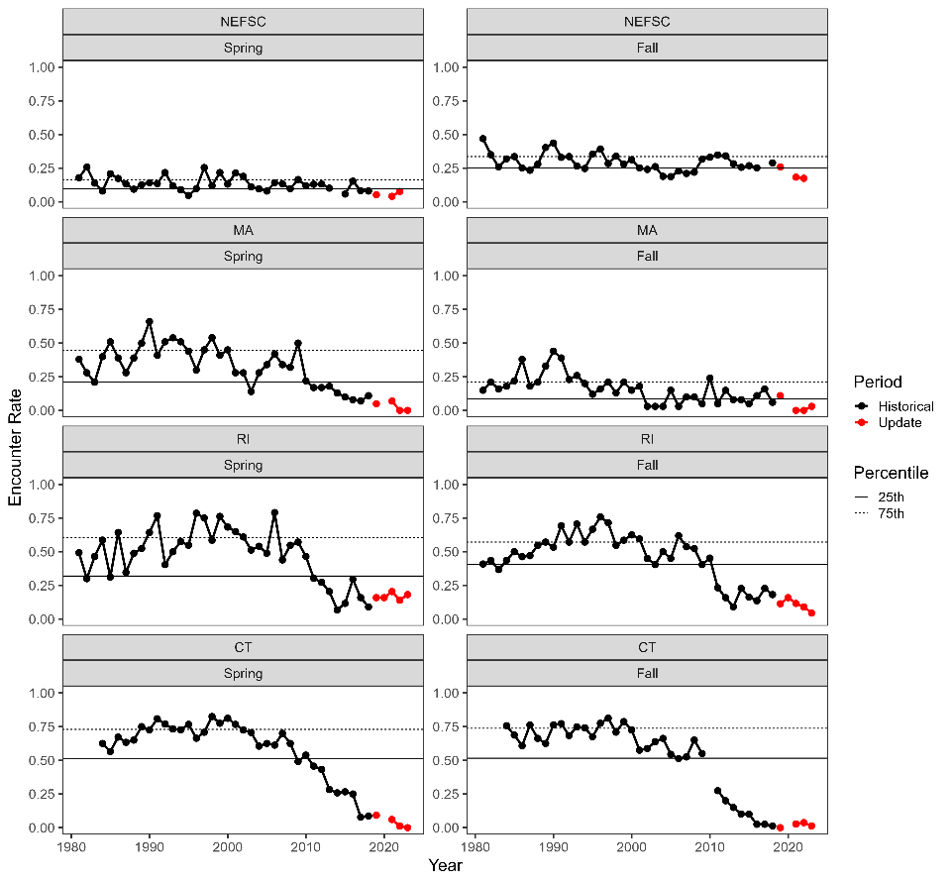

Figure 9. SNE abundance indicators: trawl survey encounter rate.

Table 10. SNE abundance indicators: ventless trap survey abundance.

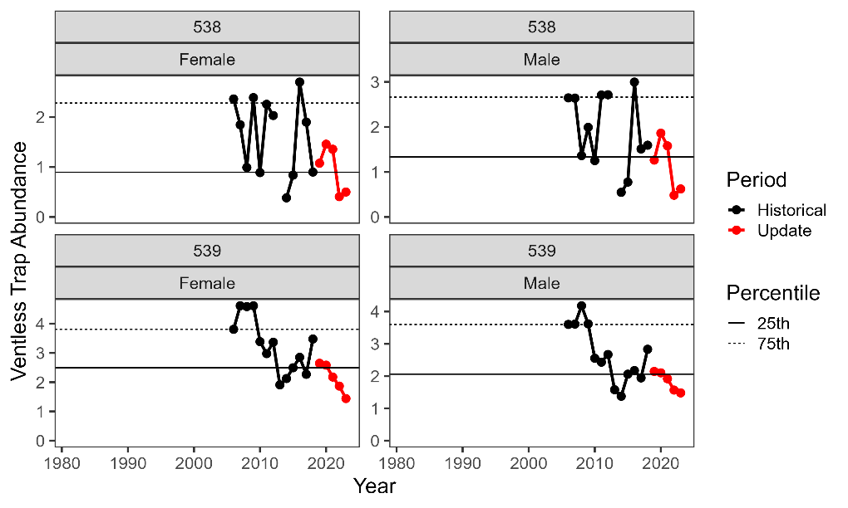

Figure 10. SNE abundance indicators: ventless trap survey abundance.

**Appendix: Data Update Data Changes**

*Rhode Island (2024 Update)*

A slightly more conservative method for identifying traps to exclude from the VTS data set was adopted during the 2024 Data Update (terminal data year of 2023). For example, some traps with a hole in the funnel or side head were excluded whereas they were not in previous years. The table below compares the number of traps retained for index calculation between the 2024 Data Update and 2023 Data Update.

|  |  |  |
| --- | --- | --- |
| Year | 2023 Data Update | 2024 Data Update |
| 2006 | 852 | 851 |
| 2007 | 848 | 848 |
| 2008 | 864 | 864 |
| 2009 | 804 | 804 |
| 2010 | 858 | 857 |
| 2011 | 858 | 858 |
| 2012 | 834 | 830 |
| 2013 | 839 | 836 |
| 2014 | 832 | 825 |
| 2015 | 854 | 846 |
| 2016 | 831 | 817 |
| 2017 | 833 | 831 |
| 2018 | 846 | 839 |
| 2019 | 858 | 850 |
| 2020 | 836 | 826 |
| 2021 | 864 | 851 |
| 2022 | 861 | 815 |

The only change in conditions the data change causes is for 2019 and 2020 annual values for both sexes which change from negative conditions during the 2023 Data Update to neutral conditions during the 2024 Data Update. The terminal five-year means are negative for both sexes during both data updates.

*Maine (2023 Update)*

During the 2023 Data Update (terminal data year of 2022), a few errors were found in the upload process where data was not uploaded correctly and treated in a consistent manner as the assessment. For the Fall 2021 ME/NH Trawl Survey, the sex of sampled lobsters did not upload correctly, leading to 7 tows being excluded in error. These data have now been corrected and included. During the 2020 assessment, the stock assessment team, in consultation with survey staff, determined that a very large outlier tow in the Spring 2014 ME/NH Trawl Survey should be excluded from the assessment. However, this outlier tow was not excluded in the 2022 Data Update. It was excluded for the 2023 Data Update, consistent with the stock assessment. For the Maine settlement survey, data for 2013 was not uploaded completely and this has now been corrected.

*Massachusetts (2023 Update)*

Following the 2022 Data Update (terminal year of 2021), an error was discovered in the data pull for the SNE VTS index that did not filter the frequency of trawl hauls per month in historical data to match the reduced sampling frequency in data since the footprint reduction (see below; reduced to 1 haul/month). This error was corrected in the data pull for the 2023 Data Update.

*Massachusetts (2022 Update)*

Following the 2021 Data Update (terminal data year of 2020), there was a reduction in the spatial coverage of the SNE VTS (Statistical Area 538) due to reduced participation. This change necessitates dropping out data collected during earlier years from areas no longer sampled to calculate an index from a consistent survey footprint, resulting in changes to the indices. Note that the updated index increased slightly in scale (the reduced footprint excludes most of the interior of Buzzards Bay), but the pattern over time is generally consistent with the previous index.

*Rhode Island (2022 Update)*

Some changes to the SNE VTS Statistical Area 539 (RI) data occurred between the 2021 Data Update (terminal data year of 2020) and 2022 Data Update (terminal data year of 2021). Upon further QA/QC in site or sample location, strata classification for select stations over time were rectified. Data as such were updated to reflect these changes during the 2022 Data Update.